Understanding Family Finding, Relative Assessment and Approval

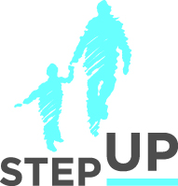
Presenters:

Ana Beltran
Sue Abrams
Martha Matthews
Angie Schwartz

stepupforkin.org

This certifies that attended the 2 hour Understanding Family Finding, Relative Assessment and Approval Webinar Training on August 17th, 2016.

Attendee Signature Angie Schwartz

