Understanding Confidentiality Rules

Presenters:
Martha Matthews

Alyssa Skolnick

Mary Sheppard

Angie Schwartz
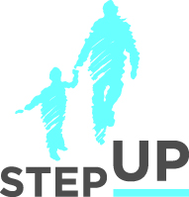

stepupforkin.org

This certifies that attended the 2 hour Understanding Confidentiality Rules Webinar Training on February 22, 2017.
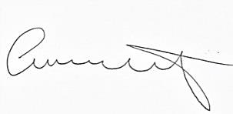
Attendee Signature Angie Schwartz

