Implementation of Resource Family Approval: overview of policies, best practices, and new tools to help relatives navigate the new system

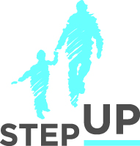
Presenters:
Sara Rogers
Kim Wrigley

Danna Fabella

Carol Ramirez

Karen Alvord

Angie Schwartz

stepupforkin.org

This certifies that attended the 2 hour Implementation of Resource Family Approval: overview of policies, best practices, and new tools to help relatives navigate the new system Webinar Training on January 25, 2017.

Attendee Signature Angie Schwartz

