Continuum of Care Reform and Improving Education Outcomes
for Foster Youth in Residential Programs

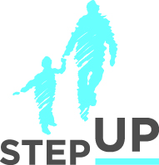
Presenters:

Chanel Boutakidis
Danielle Mole
Martha Matthews

stepupforkin.org

This certifies that attended the 2 hour Webinar Training Continuum of Care Reform and Improving Education Outcomes for Foster Youth in Residential Programs Webinar on July 20, 2016.

Attendee Signature Angie Schwartz

